The Month of Adar

Time is both a construed idea and an inherent characteristic of the natural world. It is when these two realities-one a reality of nature and the other a reality of our consciousness-merge within an ideology, can the idea of a spiritual or religious cyclical understanding of the year be elucidated, traveled and worked with.

Time is not a physical entity that we can see and touch; yet we are seen and touched by it. Our cognitive selves can find this an untenable spot. So if time marks us then we will mark it right back! We are thinking, observant creatures, and as such we need something to watch and think about. We watch the earth and notice repetition. A season comes, goes and then comes back again. A child is born, grows and has a child. We begin to see a pattern. We soon count on this as a point of reference. This repetitive cycle serves as the parameter within which we focus and use as a framework to understand and place our lives.

Perhaps the adage ’ To ride the waves of time’ is more truthful, good old-fashioned advice that we know? We cannot stop the ocean’s waves. Once we swim to the top of one, we have no choice but to ride it out till it has come to rest on the shore. We do not control it. A wave is the natural force that exists because that is how the ocean behaves. It is inherent, as it is part of the ocean’s oceaness.

Over the course of our human history time has accrued layers of meaning. Time is eternal; we, however, are not. We are temporal creatures. Time continues; we do not. Eventually even our tikkun ends and we no longer need to reincarnate. Granted, for most of us it does feel as though we come back to this plane for eternity, we do at some point return to the source.

The Jewish concept of time, or rather the concept of beginning and ending is quite complex. The Jewish year has more than one beginning and end. It has more than one measurement of time. The most ‘known’ and ‘obvious’ years are those of Nissan through Adar and Tishrei through Elul. The first is the community year and the second is the spiritual year. Of course this is a generalization for this discussion.

We are perpetually at the beginning, middle and end of all the cycles at the same time. The Kaddish is perhaps the most profound expression of this thought. It is said for the dead, yet it speaks only of G-d and the future. The Kaddish is also recited after we have finished a learning and after certain parts of the service. It is an energy seal used again as a point of closure and a point of entrance. The past and future come together. Time as a flowing, liquid marker of our ‘beingness’ is truly part of the divine essence of the Creator. Understanding time and working with time is one way for us to relate and connect to holiness. We express ourselves to G-d through our actions, our ceremonies, and our relationships through these various ‘wheels’ of the year. This is a way for us to express our spirituality. Time is a pivot and an axis on our path to a relationship to each other and the divine.

Qualities of Adar

Adar is the last month on the wheel of the community year. We start to put closure on the year. But as with all endings, there is also an inherent beginning. For something to end there must be something new waiting to begin; otherwise how could we conceive of something new and beyond where we are. So in Adar we begin to end and end to begin. Adar is about being in these two places at the same time. Elul-the last month in the spiritual year wheel has a similar function. As such they share certain traits. In both these months we do Tshuvah and ‘fix’ the ‘sin’ of the Tree of Knowledge. And of course we also look forward and backward.

Although each month has its specific energies and spiritual lessons and qualities, the complexities of the Jewish philosophy weave themselves together in a tapestry that makes a complete guide, with each month telling its own story and giving us its own ‘work’, or lesson plan for us to follow.

Purim and Tshuvah
One of our tasks is to do Tshuvah-to repent. Tshuvah means ‘to return’. But return to what and why. Typically when we think about repentance, we thing about the holy day of Yom Kippur when many of out prayers are turned toward asking for forgiveness for the transgressions we have made during the past year. We pray that we can be forgiven for our mistakes, those made by us on a conscious, as well as an unconscious level. There are times when we all do things, say things and even think things that we know are wrong but we do them anyway. There are also times when we do these same things through ignorance. We may have hurt someone else’s feelings without even knowing it. These also need to be taken into account during our tshuvah process.

Is there a difference between the tshuvah we make on Yom Kippur and the tshuvah we make on Purim? On Yom Kippur we are at the beginning of the new year of the universe, as well as the new year of the spiritual, or the religious year. This wheel of the year takes us through the steps of the first spark of creation of the world. Our souls begin as the little sparks from the above and slowly grow from a newborn spirit that has been put into a physical body. It is the continuing growth of our ability to live, to see, to experience, to create, to understand our connection to the divine, to grow our ethical, creative way of being in this world. It is universal as well as very personal. This wheel is about the role that we all play in being creatures of the spirit. The tshuvah we do during the month Elul is about our lives seen through the window of the soul.

Purim’s tshuvah is about the way we are in a group that is already ensconced in the physical and our deeply personal psyches. It is a ‘given’ that we are souls in bodies. We are past that awareness and now have to build our house, so to speak. This wheel presupposes the consciousness of being in the physical and looks to grow into a community where we manifest our spirits on the earthly plan. It is about dealing with our personalities as well as about being a group and how that group functions as a cohesive whole. Some may say that this wheel is more grounded in the earth while in the Spiritual wheel, when we see a mountain we see a great metaphor of the divine, in this wheel we see the mountain as a place that is our home and our home must be taken care of. Here is where the weave of the tapestry can overlap, as we also always need to keep the spiritual in the forefront of our actions and lives because it is the spiritual pattern which sustains us, just as the other wheel needs to keep the physical in mind as well, as that is what we have through which to do our spiritual work. Our spirituality is housed in our physical world and our physical world is imbibed with spirit. The metaphor is the concrete as well. The metaphor is the map. Hence this wheel that we have created is the manifestation of the spiritual truth that sustains and creates us

The Secrets of the Hammantachen

So just when you think you have it all figured out, when you spent the year learning and growing and getting a clear picture of ‘reality’, the real reality trips you up. Haman thought he had it made. He just knew he was going to be the top man. But the only thing he was on top of was the gallows. In other words, things are not always as they seem. This is Adar. It is a month about seeing the truth instead of letting ourselves be deceived by what looks real and good. The month is about the hiddeness of this truth and learning how to see it. Adar is about endings and resolutions, vision, joy, the future. We are getting ready for the great liberation from slavery by remembering our redemption in Persia.

Women have a special relationship to Adar and Purim. Vashti and Esther were both important and strong characters who are healthy role models. Vashti has been wrongly demonized by some, but her actions and choices are as vital a teaching for women today as are Esther’s. They are sisters and so they should be ours. They show us the possibility of solidarity, courage, conviction and boundaries.

Purim also occurs in Spring, when fertility of all of Nature was celebrated by those of faith that was earth oriented. This path has influenced the Jewish path. Just as Rosh Chodesh was originally of this older path, so might be elements of Purim. It is believed that the Hammantachen was first a pastry that celebrated the feminine aspect of fertility and spirit.

Adar is also about our connections to each other and to God/Goddess. It is about commitment to our beliefs and actions-both private and public. This month tells us that what is above is also what is below. If we want the divine presence in our lives there is the path for us. There is a way and this month teaches us what that is. This month is about the action of reverberation. The seen and unseen, the holiness and the profane, the choice to take action or not, are all part of the message and hint of the work we can do.

Adar is about hiddenness; hiddenness that supports the obvious. The Jews were about to be wiped out by Haman. Esther was, on the obvious level, the Queen; but on the hidden level she was a Jew. It was this hidden aspect of her that saved the Jewish world.

This is a great illustration of the concept of Tzimtzum. According to Kabbalah, the world was created by the breath and word of Spirit-the Divine Creator/Intelligence. It removed ‘itself’ from the place that was to be our universe. This process, this contraction, is called Tzimtzum.

But I offer an additional way to understand Tzimtzum, especially illuminated by Adar and Purim. Instead of thinking of Tzimtzum as a removal and absence, think of it as concealment or hiddenness. By being hidden, there is still support, but it cannot be seen unless we are shown how to see. Purim is on the way to help us with this.

The Sepher Yetzirah is a Kabbalistic text that illuminates and describes the structure of the worlds-spiritual and physical and consciousness. This is metaphorically illustrated in a diagram called the Tree of Life, which when seen from a three dimensional perspective forms a cube. Each month has letters, planets, sfirot, signs, tikkun-spiritual and emotional fixing- and directions attributed to it. Each direction of the cube is a gate that depicts the path a soul can travel towards the ultimate spiritual illumination. In modern times the Tarot has also gained a place on this cube. The place on the cube of the Sepher Yetzirah for Adar is in the South Below.

Adar is the sfirot of Chesed on the tree of life. Chesed is the holy spiritual water and it spreads out and encompasses all. It joins us to the universe and to each other. It is beyond individual physicality as when water flows over all it makes us all one. When we give Shalach Manot to each other we hide ourselves; our individuality has no bearing. This giving is about giving to each other as one unified people.

When we dress in costume we are not ourselves. We are the deception turned holy. We do not recognize each other by name. We recognize each other by something deeper. We know each other from a place of true Chesed. We tell each other that although I cannot see your ‘real’ face, I still know you because I can see and feel your real spirit through your costume. When I feel with truth and pure intuition, when I have turned my illusions and negativity into purity, then I cannot be deceived for I stand at the gate of truth. I am at the door of higher awareness and spiritual authenticity.

Pisces is the astrological sign for the month. Pisces is about the whole. Pisces is about consciousness that is not bound. Like fish that swim in the sea, we are part of the universal mind, which like water, flows over and around all it encounters. It is the ultimate rendering of Chesed. Pisces reaches into the deepest places of the mind and soul, yet lives in the material world as well. The two fish that swim in opposite directions depict this.

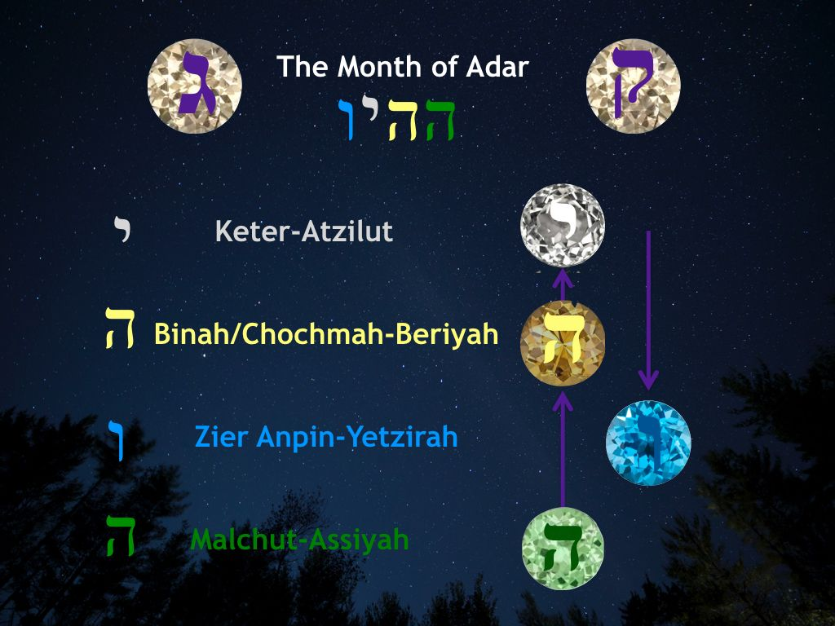

The permutation of the month is Hey Hey Yud Vav. The first Hey is the sfirot Malchut and the world of Assiyah-the world of the physical manifestation. We start out very much on the Earth in Adar. We look back on the past year and evaluate ourselves. Did we do everything we set out to do? How much did we fail and how did we handle it? Did we learn from it? What about our success? Did we remain humble? Did we love enough? Did we pray enough? What do we still need to fix?

The second Hey is the sfirot Chochmah/Binah and the world of Beriyah-the world of soul. How do we understand all that we have just examined about ourselves on the earth? How do we approach these questions and find the answers? Where is our intuition? We need to raise our heads a bit and lift our feet a little off the ground, for the answer is with spirit.

The Yud is the sfirot Keter and world of Atzilut-the world of the most high. Where is the key to seeing the answers? Where is the source of understanding? We go a little higher and see a little more light as it is shed on us. We are near the spirit hole. Now we can barely feel the earth. Our minds and souls expand just a bit as the opening is made. But at this point we must turn away from this light. We cannot go through this spirit hole, we can only bow before its power.

The Vav is the remaining sfirot of Gevurah, Chesed, Tiferet, Netzach, Hod and Yesod called Zeir Anpin and the world of Yetzirah-the world of formation. We start our descent. We go from the Yud, to the Vav. Zeir Anpin is the cloud just above our heads that we can see and almost touch. It is the filter through which we work the answers until we are back on the ground with new visions, strength and resolve.

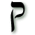
The letter of the month is Kuf. Kuf is the letter of deception and holiness. The word itself means to ‘copy’ and also to ‘touch’ or ‘surround’. Monkeys are natural mimics. They are the grand universal actors. They imitate with aplomb and show us our foibles and charms.

It is also associated with the occipital lobe and the eye of the needle or the hole in the axe blade. The occipital region, back of the head, is where memories and secrets lay and connect to the unconscious. The needle is used to repair what is torn or create new, while an axe blade can kill. Kuf can do either.

We can be surrounded by the light of purity or the darkness of the klipot. Kuf begins such words as Kedushah-holiness. It also begins the word kelipah-unholiness. The numeric value of the letter is 100. This is 10 times Yud. Adar gives us a direct tool with which to work some of the negativity we have into the positive. Through the action of the Kuf we can transmute the dark into the light. The energy of the Kuf operates as a spiritual elevator. It travels between the spiritual realm and the physical earthly realm-the above and below.

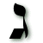

The letter for the planet Jupiter is Gimel. This is the letter of nourishment, meting out of reward and punishment, connections and the impetus for the light that runs back and forth between spirit and this world, it also runs to help those in need. Like the camel, Gimel can go long, dry periods and traverse long distances. The energy of Gimel is that of balance. It can bring two forces, for example, the seen and the unseen together and create unification. Like Jupiter, it is generous with what it gives and takes. We have the will to choose our actions and this letter helps us define, explore and reap what we choose.

The Tarot card Adar/Pisces is The Moon and for Jupiter is The Wheel of Fortune. The South is the direction of the hidden mysteries and initiations that leads to enlightenment. Purim is about hiddenness and deeper knowledge as well. The initiate must develop higher spiritual sight and stir the beginnings of inner wisdom or else ever remain just the seeker. No initiation comes easily. Demons must be faced and conquered and understanding and appreciation of the meaning of this work must be committed to.

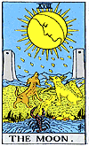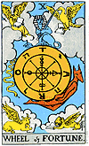

The Moon is a very apt card for this very task. The moon sits in the sky in all its phases at once. Below the moon a pool of water swells into a path that leads through two obelisks towards mountains in the distance. A lobster/crayfish is perched partly on the grass. A wolf and dog sit opposite one another and howl up at the moon that is raining down moon water drops that are shaped like the letter Yud. This is the path to other realms. We have to feel our way through it. It is time to face our own hidden parts. The howling of the beasts sings these parts to the surface of the water. The moon’s light is not its own yet it offers us illumination that direct light cannot. The light becomes transformed by the moon and cannot be contained by it. It rains down droplets of illumination: the first letter of the Tetragrammaton, the first sparks.

Here is a key to understanding Adar and the work we have before us. We stand between the waters of the deep and the waters of the high. Our souls become engaged in this conversation and here we can take our next step. The two towers in the card beckon us. They open to an expanse beyond. But first we must arise from the waters below that team with creatures who live in the murky darkness of our own intuition and unconscious held in chains.

The other card for the month is The Wheel of Fortune. This is the card for Jupiter/Gimel which is the planet of expansion, beneficence and luck. But first we need to explore what luck is and is not. Luck, the common concept of luck, is a spiritual misnomer. If all happens as it should, if we all get what we ‘deserve’ from whichever lifetime or circumstance it springs, then the seemingly random occurrence that is called luck, should not happen, if what you call luck is that thing that happens out of the blue with no basis in logic.

Perhaps the Wheel of Fortune is missing the obvious element that would help us to see a deeper meaning of the card. But then again, to be that obvious would also not be true to a deeper meaning of the card, which is to take a turn with the invisible source of action of the universe; in other words, have enough faith-blind or otherwise- in the machinations of the divine intelligence that the compassion-however harsh it may seem, will wash over us, if only we would stand under the wheel and let the water, that we can only see with our faith, cleanse us and help us to swim the tides of our lives. The Wheel of Fortune can help us with this and is an elegant illustration of this concept. The wheel never stops turning. Its motion is constant, yet its center is strong and supportive. Without a strong center the wheel would wobble, teeter and just make a mess. You can’t ride a Ferris wheel if it is unsteady. The Wheel of Fortune also is about what we yet have to learn and complete. To which of the books is the wheel going to point us? When paired with the Moon and the lessons of Adar we are being pointed to open the book of our subconscious. Before we can start the new we have to finish with the old; hence the following meditation and the importance of Tshuvah.

Meditation for Megillah Reading

One way to experience a Megillah reading is to make it loud and gregarious. When the name of Haman is read, all take their noisemakers and clack away till our hands are tires. Or for lack of a grogger, stomps, yelps and clapping will do. This is what most of us were brought up with, and while it is fun and brings us back to a nostalgic place, for better or worse; there is another way to read the Megillah which is strong in a whole other way.

When we read the Megillah and Haman is mentioned we draw the Kuf down into ourselves and release it along with what we need to make right and what we need to release. This is a fast action like water that flows over a waterfall. This is one reason why we read the Megillah fast. We need to hear every word but we need to hear it as one unified song of our spirits and hearts so we can travel together with no hesitation. When we hear Haman’s name we tap our feet at once and we open our crowns and in that split second we bring the Kuf into us where it is collecting our negativity and what we wish to get rid of, and then just as fast as it entered it leaves us taking all of this ‘stuff’ with it. It is a lightning flash moment that leaves us transformed. As Haman is mentioned a number of times, we have many chances to clean ourselves out.

When Esther and the people fasted and prayed for three days, they did it together as one unified force with a common goal. When you fast you leave the physical behind and give yourself over to Spirit. We fast and pray for and with each other. (although the Fast of Esther is traditionally only done by the oldest male, many do it as a matter of spiritual course) This is the power of Adar. We are connected.

We aim to end the year and begin the new one with a clear head and heart. We hope to have grown enough to see through falsehood and know when we see and hear the truth. To see the truth and see through illusion is to see the divinity in all. It is to see the real thing. A true vision sees all. It sees our place in it and it sees our place to come. This vision can do nothing but laugh at our constant mishaps as we scurry to get our vessels ready for our ‘great awakening’.

The tikkun-fixing- for the month is laughter. When we understand that we are part of eternity, when we feel our eternal essence, then we lose our limitations and can see things in a new way. We begin to feel the true G-dly joy and bliss of which we are part and we see the absurdity of the boundaries we put on ourselves. We laugh at this absurdity because it now seems so funny. We now see that there is a divine hilarity to life. And so now we laugh our new laugh and dance our new dance.

